Compare different model to know the impact of pathogen mortality.
1. Single strain model with no H (i.e., S and P1)
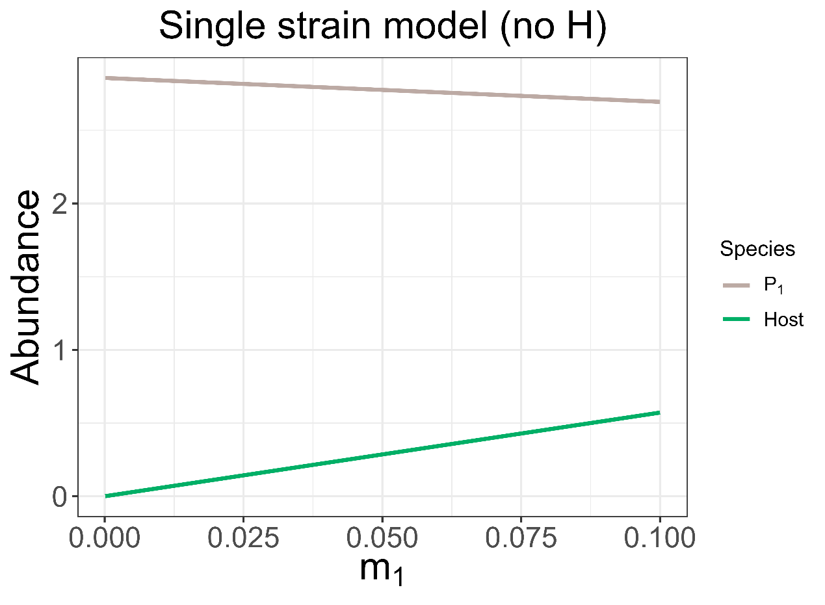

2. Single strain model with H (i.e., S, P1, P1H, and H)
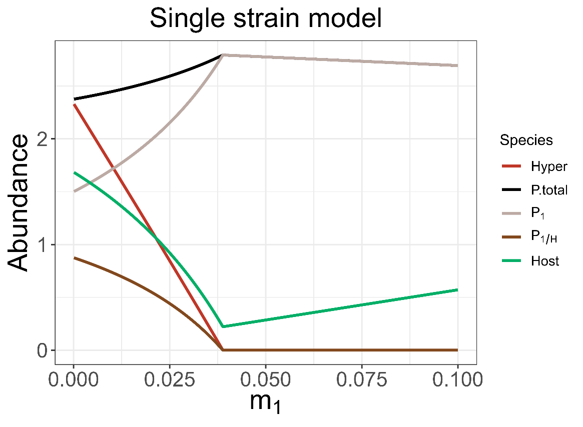
(α = 0.35, β = 0.2)

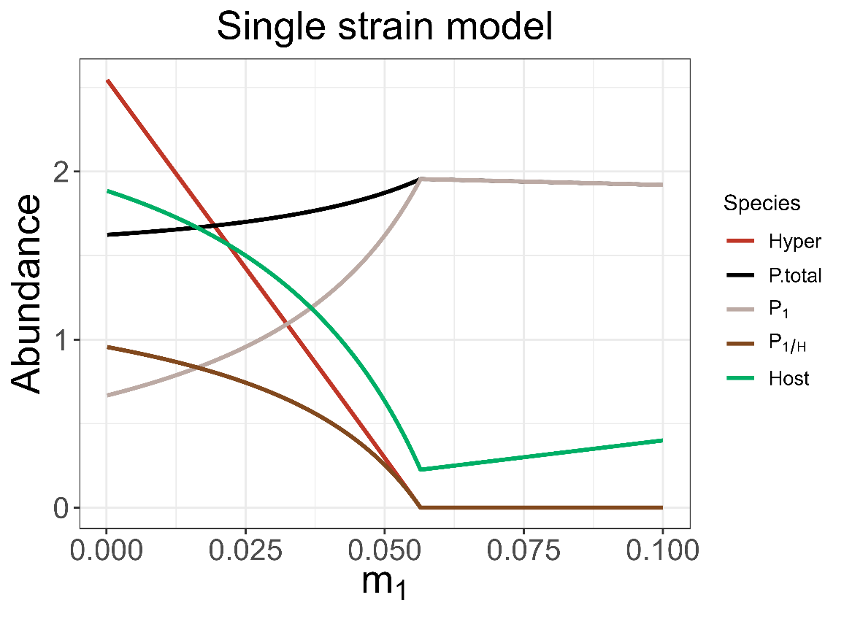
(α = 0.5, β = 0.45)

The results show that increasing of $m_{1}$ will increase $P_{1}$’s abundance when H can persist.
The reason why increase in mortality will increase pathogen’s abundance is because less hyperparasited pathogen is produced.

當兩者同時競爭時，死亡率的提升對於兩者的影響差異不同，使一方容易勝出。

